PSCP Administrative Documentation
2010-01-13

This document provides instructions for administering the PSCP website. The topics covered are focused on the PSCP application administration, not the underlying operating system or software packages. The “PSCP Website Developer Documentation” provides additional technical information.

The following activities are discussed:
- Admin interface
- Manage Users
- Upload Stations
- Upload Products
- Other functionality
- Diagnosing problems

1. Admin Interface
To gain access to the admin interface, click the Admin link in the header of the home page of the application. The user will be prompted with a login dialog. If the login is successful, the administrative interface will load. If the login fails, a standard error page will be shown and the attempt will be logged (see section 6 for log location).

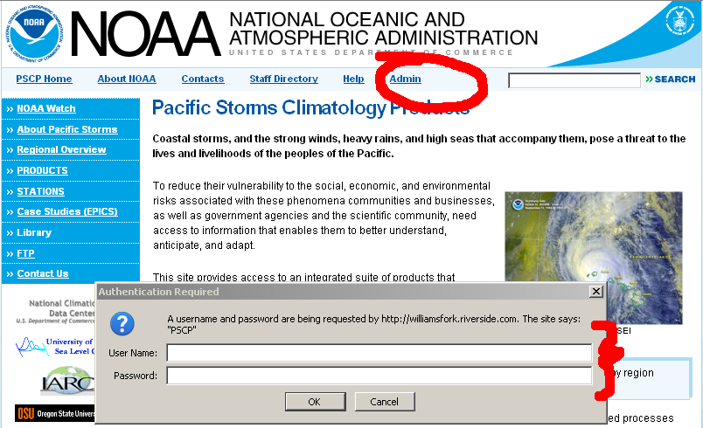
login.png
Partial view of home page with login link and login dialog shown
Once login is successful, the administrative page will appear. The main administrative activities are presented on the left, with additional links in the header for logging out, returning to the admin home page, or accessing the API. The currently logged in user appears in the header on the right.
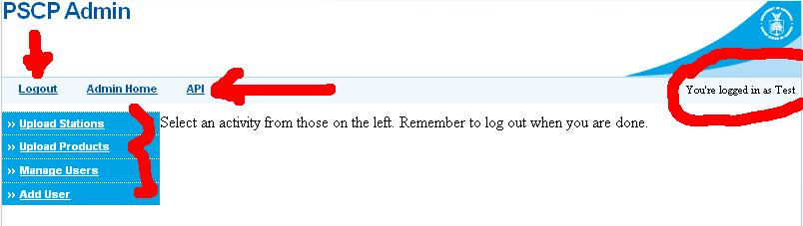
admin-home.png
Partial view of admin home page

2. Manage Users
The PSCP application manages user accounts (contacts) for two purposes: 1) Allow uploaded products to be attributed to the provider, and 2) Support password controlled administrative access and authorization.

At least one administrator is required to allow uploading stations and products to the application. Contacts are not required to have a password – this results in an “inactive” account that does not permit login. Products can still be attributed to this user during the product upload process.

To view existing accounts and information, select the “Manage Users” link on the left. The list of contacts and their attributes will be displayed. The contact name is a link leading to an editing form. If the currently logged in user is not an administrator, the only link active will be his or her own.
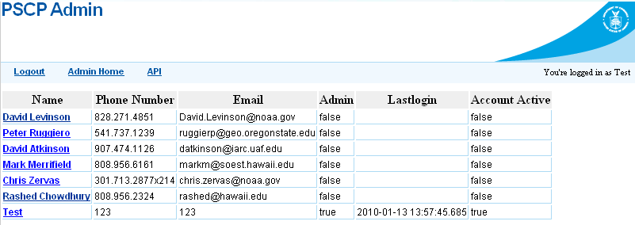
contacts.png
Partial view of contacts listing
To edit a contact, select the link on the left. A form for editing the relevant fields will be displayed. If the current user is not an administrative user, the admin and account active fields will not be displayed. The following image shows the edit page for the test account.
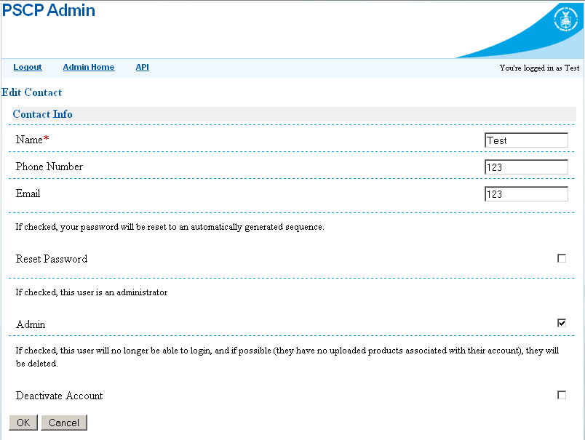
contact.png
Partial view of contact edit form

There is currently no ability to supply a password – instead a contact may “reset” his or her password to a randomly generated strong password. The fields for phone number and email are not required and there is no verification of formatting.

The “deactivate account” functionality will do one of two things, so use with caution. If the account has any products associated with it, it cannot be deleted due to foreign key constraints in the database. Instead, the password will be set to null – resulting in the inability to login. If there are no products associated with the contact, the record will be dropped from the database.

To add an account, use the “Add User” link on the left side of the admin home page. All of the options should be present except the “Deactivate Account” option.

User accounts are managed using the contacts table in the database. If all else fails, changes can be made using a database tool. The most important thing to note when doing manual changes is that Postgres does not support UUID generation directly nor does it support the password encryption/decryption scheme for password safety. For now, these must be generated using the interface.

3. Upload Stations
To upload stations, select the “Upload Stations” link on the left side of the admin home page. There is only one required field, the stations Excel file. Options to assist in uploading include:
- Dry Run – Do nothing but report on what would happen. This is useful for ensuring data is valid.
- Allow Update – If selected, existing stations will be modified. Otherwise they will be skipped. This is useful for making modifications (or ensuring only additions occur).
- Create Operators – The database maintains a list of unique operator names. If this is checked and a station has a new operator, this will allow it to be added. If this is not checked and a station has an operator that does not exist, the station will not be added (with the appropriate message displayed). The latter is useful for ensuring that operators are not misspelled. It is suggested that this be selected during normal operations.

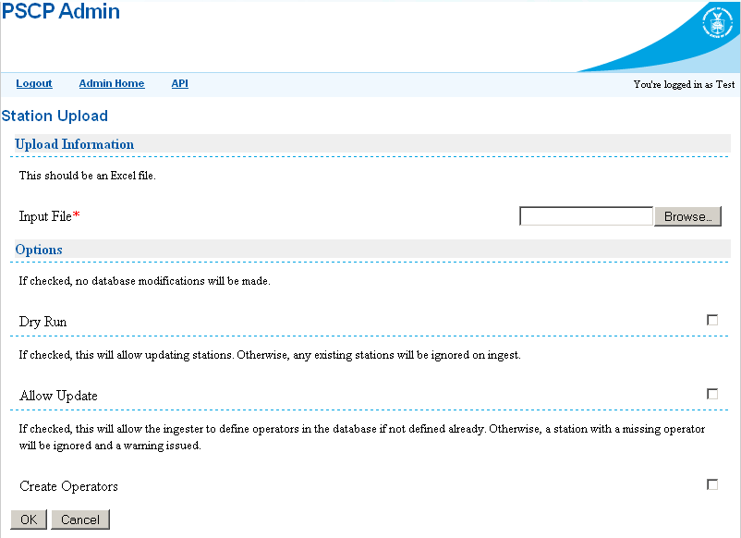
stations-upload.png
Partial view of stations upload form

When the OK button is pressed, the file will be uploaded to the server and ingested. The result status (see next figure) will appear when complete. If the upload was a dry run, this will be noted at the top of the returned results. The results will be organized hierarchically, with the file name at the top, followed by the names of each sheet and messages for each station/dataset pair contained within. The very top of the results page contains two links that allow filtering of the results: “Only Warnings” and “Show All”. Results are shown in three colors: green, yellow, and red. The latter two can be interpreted as warnings with increasing severity. The former is a success. The following image shows the results of a dry-run on an already loaded set of stations.
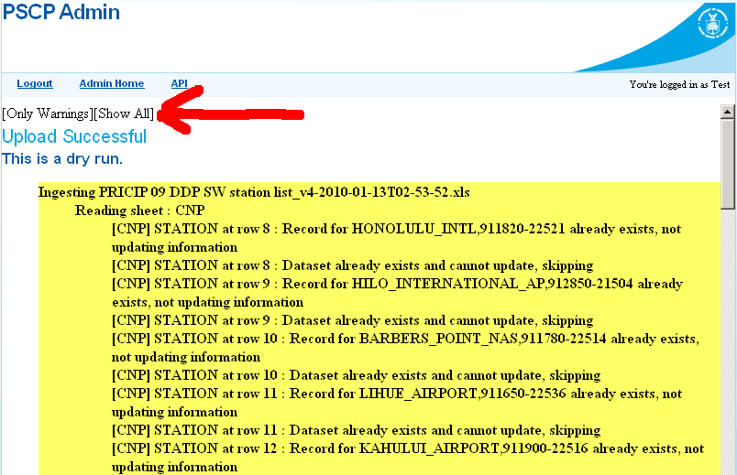
stations-upload-results.png
Partial view of stations upload results

Uploaded files and the associated ingest logs are stored in the location on the server specified during installation. If no special location was specified, the default is C:/pscp-uploads. If this directory does not exist, then the location is ${tomcat.home}/temp/pscp-uploads.

The uploaded files are timestamped to avoid being overwritten and placed in a directory that is named after the currently logged in user’s UUID. The log of a given upload is the same name as the uploaded timestamped file with the suffix “.log”.

4. Product Uploading
The product upload procedure is similar to the stations upload. Start by selecting the link on the left of the admin home page entitled Upload Products. The options for uploading products include:
- Dry Run – This is the same as the stations upload option.
- Submitter – If the currently logged in user is not the creator of the products, this allows the correct creator to be attributed. This is useful if it is decided that collaborators cannot upload their own products and instead, the admin user will do it for them.
- Create Product Definitions – If the product definition does not exist yet, this allows for them to be automatically created. If the product is the first revision, then this must be checked to succeed. It is useful to leave this unchecked when performing subsequent uploads to ensure that incorrect products have not been specified.
- Auto Revision – If this is checked, the uploaded products will be considered the most recent revision. For now, this is the only way to have products appear to the end user. One goal of the revisioning feature was to allow collaborators’ products to be reviewed and approved before becoming visible to the public. The other goal of tracking multiple revisions is still supported.
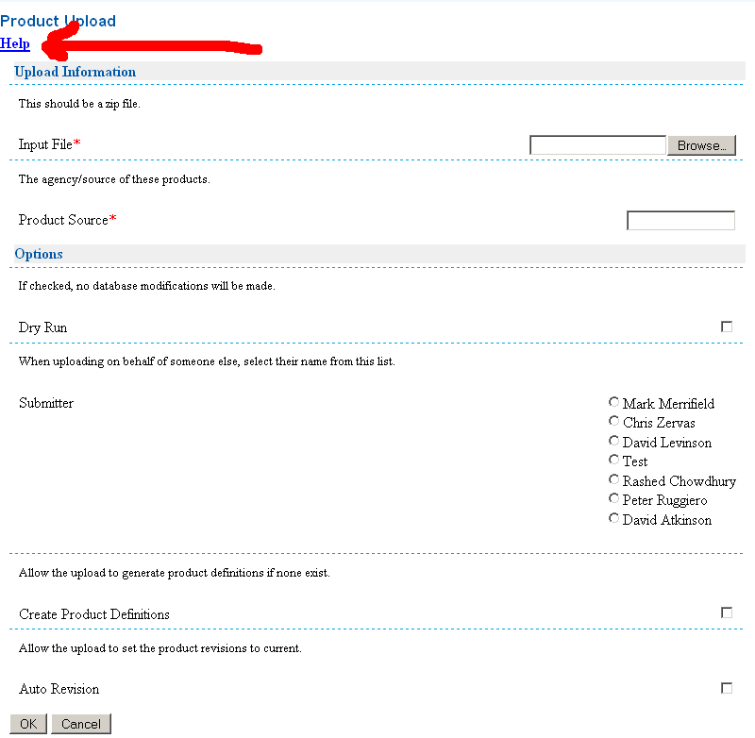
products-upload.png
Partial view of product upload form

The products upload will provide results similar to the stations upload procedure. If the upload was not a dry-run, the uploaded products will be extracted from the zip file and scaled to thumbnail size in the “background”, as this is a time consuming procedure. As a result, they will not be immediately visible. To track the job status, click the API link in the header of the admin pages (see Other Functionality). This process may take several minutes to complete.

The products will be archived on the server according to the logged in user (not the optional submitter), similar to the stations upload.

To control the exact location of the archived products, set the value of the pscp.product.root parameter in the web.xml file to the fully specified folder where you want the product files to be placed. If you change this value, be sure to bounce the server before using the Upload Products feature.

5. Other Functionality
The API link in the header of the admin pages leads to a list of links providing additional functionality. Some of these are used by the admin pages noted above and others are used by the public facing web pages. The more useful links/functions are noted here:
- products
- producttypes
- stations
- admin/batches
- admin/refresh

Diagnosing Problems
For security purposes, any unforeseen error messages (beyond a generic message) are not relayed to the clients. Instead, the application components (both PHP and Restlet) will log to files on the server.

The PHP error logs are combined with other Apache output and end up in the ${apache.root}/logs/error.log. Since the PHP portions of the application have a minimal number of working parts, the most likely errors to see here would be database connectivity related.

The Restlet application uses the java.util.logging package and framework which is configured by Tomcat. The default logging configuration uses logging rotation, so files will be time-stamped. The Restlet framework will log access and other messages into the “catalina” prefixed log files, while other output goes into the “localhost” files. It is typical that some non-critical errors may be logged, for example an invalid request may result in an exception internally. This might occur because a user mistyped a URL. Ensure that messages and stack traces are read in their entirety before reporting to Riverside.

Any changes that are made to the database using an external tool may not be seen by the client. This can occur for two reasons:
- The client has viewed the page before and has a modified date that is not reflected in the one returned by the URL.
- The application has cached the database query results for better performance.
Both of these situations can be rectified by visiting the admin/refresh URL in the API link.

